Water-related internal governance
The Inghams Somerville Plant Manager has overall accountability for water stewardship on the site. Production Supervisors are responsible for the use of water and discharge of wastewater in their areas of responsibility. The Advanced Water Treatment Plant Supervisors control the operation of the wastewater treatment plant and its discharge to sewer. The Health, Safety and Environment Manager monitors compliance to water-related laws and regulations and manages relationships with external stakeholders.
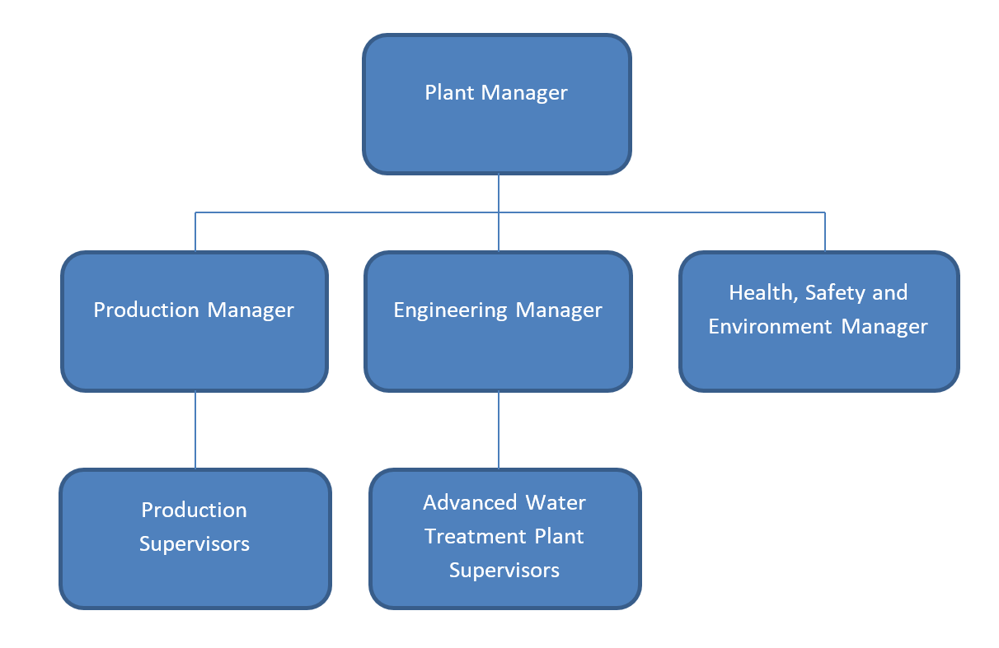
The governance arrangements for the site are communicated to stakeholders on the Inghams company website and through consultation on this Water Stewardship Plan.

 | SMART Target | Metric(s) | Action | Progress Status
Improve water intensity | Maintain water recycling to minimise water consumption and trade waste production | Maintain AWTP performance exceeding 70% recovery of incoming wastewater | Operate and maintain Advanced Water Treatment Plant to maximise recycled wastewater  Monitor and report performance | Regular preventative maintenance  70% recovery from RO’s
Improve water intensity | Re-instate rainwater recovery system to minimise water consumption | Rainwater recovery system re-instated | Re-instate return pipework for collected rainwater | To be reviewed in Q3  Currently on hold
Improve water efficiently | Use less water per Bird processed or tonne of final product | Site target of 21.34 L/Bird based (retain target from previous year - 2% reduction on FY2020 actual) | Ongoing communication of water exception alarms to relevant Supervisors  Work with cleaners to identify and implement water conservation opportunities  Implement education program to improve water conservation behaviours | Daily and Weekly Reporting and Monitoring  100% AWTP Daily Flow Master Spreadsheet
Minimise impacts to Watson Creek | Prevent contamination of Watson Creek through any action, inaction, accident or impact normal business activity | No significant spill incidents where organic or chemical contamination enters creek | Ongoing sampling and monitoring of stormwater and Watson Creek water quality  Develop SWP for stormwater isolation  Revise and recommence daily environmental walk covering surface water management | Regular testing and monitoring  100% 3 monthly testing  Daily Environment Walk conducted daily  70%
Maintain a healthy streamside environment | Maintain vegetated buffer zone around site | Completion of weed control and plantings | Undertake weed control works and tree planting as per Peninisula Bushworks proposal | Conducted yearly. Not conducted in 2020 due to Covid-19 restrictions  Currently on hold until Covid restrictions are lifted
Contribute to improved Catchment Governance | Meet requirements of the site trade waste agreement | No trade waste discharge non-compliances | Review and monitor AWTP parameters against trade waste agreement requirements  Review and submit new trade waste agreement taking into account future site plans | Regular testing and monitoring  100% AWTP Daily Flow Master Spreadsheet
Minimise impacts to Watson Creek | Cooperate with local stakeholders to protect and improve the condition of Watson Creek and the broader catchment | Proactive involvement to assist with achievement of stakeholder aims and goals | Attend over 50% of WCCG Committee meetings per year  Records of engagement with catchment stakeholders | Conducted yearly. Not conducted in 2020 due to Covid-19 restrictions  Currently on hold until Covid restrictions are lifted

Shared Water Challenges

Water Challenge | Associated public sector agency initiative | Relevance/rationale for stakeholders | Relevance/rationale for site | Rank | Rationale for prioritisation
Water quality and biodiversity in Watson Creek and Western Port Bay – Melbourne Water Stream Quality reports show high pollution levels for in Watson Creek. | PP&W CMA Catchment Plan  Melbourne Water Streams & Waterways quality goals  Parks Victoria Yaringa Marine National Park  Co-operative of SE Melbourne Councils supporting Westernport Biosphere Foundation | Western Port Ramsar wetlands and Marine Park. Important for birdlife, fishing, environmental diversity | Pollution discharges to creek are regulated by EPA and could result in regulatory action.  Important for public reputation that site does not pollute creek  Important for reputation that previous commitment to Watson Creek not be seen as mere ‘green wash’ in event of changing corporate focus | H | - Valuable, moderate - minor cost to regularly sample creek upstream and downstream of site to create record of performance  - Need to ensure and demonstrate Inghams Somerville PPP not contributing to pollution
Limited municipal effluent treatment capacity – South East Water Mt Martha STP | SE Water Corporation - Mt Martha STP upgrade for improved quality discharge and recycling for irrigation  Melbourne Water discharge to Boags Rocks Port Phillip  EPA Victoria | Capacity limits – infrastructure improvements  Influence on Boag Rocks discharge into Port Phillip – amenity value, social, fishing | Important to meet trade waste limits for volume and quality – economic cost of volumetric & quality charges  Important to not give cause for additional TW restrictions that may restrict production or add economic costs | M | - Valuable, long lead time normally for change may limit site economic (capacity) growth  - Need for discussion with SE Water as Somerville PPP capacity increase planned so that SW can ensure infrastructure capacity remains adequate
Waterways and wetlands ‘Water Important Areas’ management and improvement goals of Governmental and non-governmental agencies | Westernport Biosphere Foundation  PP&W CMA  Melbourne Water  Parks Victoria  Co-operative of SE Melbourne Councils  Mornington Landcare Network | Attempts to reverse environmental degradation associated with development  Attempts to implement WSUD principles to reduce peak stream flows after rain due to very rapid runoff from hard surfaces | Important for public reputation that site contributes to community goals | L | - Valuable, moderate - minor cost to participate in stakeholder activities such as Landcare groups etc  - Partial funding available from public sector actors reduces commitment costs
Limited capacity of water resources and increasing water costs for community | CRC for Water Sensitive Cities  Melbourne Water  Mornington Peninsula Shire  WSA | Best practice water intensity and water efficiency  WSUD  Integrated water management | Important to show that our operations target/approach/meet or exceed best practice water use for potable, trade, waste, storm and rain waters management | M | - Valuable, economic – use less water reduce cost  - Valuable – stakeholders see Inghams as low risk/high benefit to infrastructure, environment, community
Climate variability Extremes weather events Drought water scarcity of larger catchment – cyclic (currently no scarcity) | Melbourne Water  CMA  SE Water | In drought conditions Melbourne Water may have limited supply available to distribute to customers | Important for public reputation that site not be viewed as a wasteful major water user in times of scarcity or to have limitations on water imposed as this would have negative economic consequences to business | M | - Not currently in drought due to long term storage capacity of Melbourne Water reservoirs.  - Permanent water restrictions apply  - AWTP capacity demonstrates efforts be water efficient and self sufficient  - Cyclic weather patterns becoming more extreme.

